Simulación

Tabla:

|  |  |  |  |  |
| --- | --- | --- | --- | --- |
| *n* | *x* | *y* | *z* | *F* |
| 0 | 0 | 0 | 0 | 0 |
| 1 | 0 | 0 | 1 | 1 |
| 2 | 0 | 1 | 0 | 0 |
| 3 | 0 | 1 | 1 | 1 |
| 4 | 1 | 0 | 0 | 1 |
| 5 | 1 | 0 | 1 | 1 |
| 6 | 1 | 1 | 0 | 0 |
| 7 | 1 | 1 | 1 | 0 |

Circuito completo: *F* = *x’*(*y’*+*z’*)*’*+*y’*(*xz’*+*z*)

*Casos que encienden.*

*n* = 1, 0 0 1

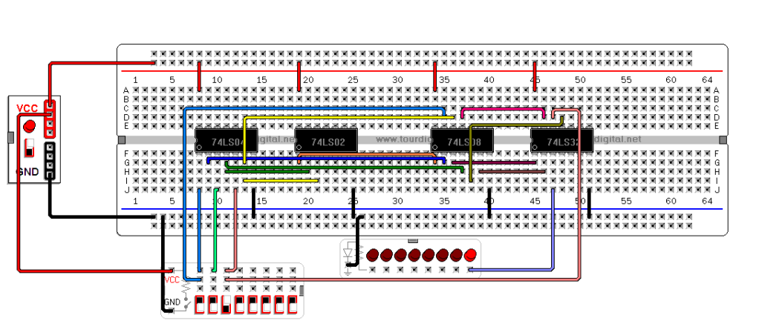

*n* = 3, 0 1 1

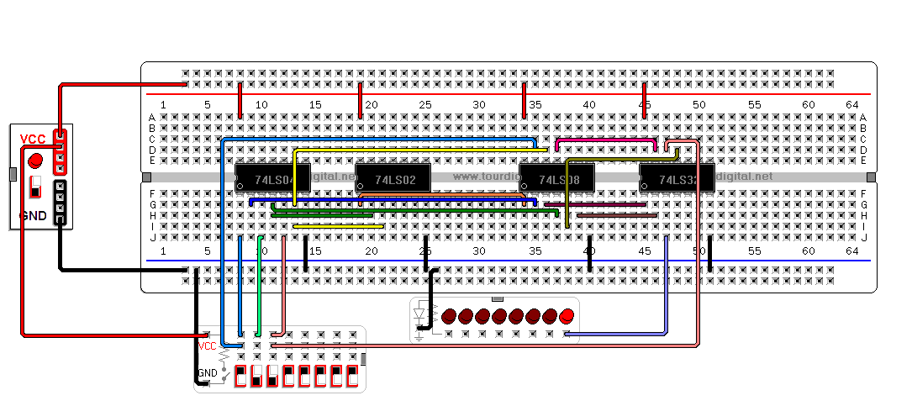

*n* = 4, 1 0 0

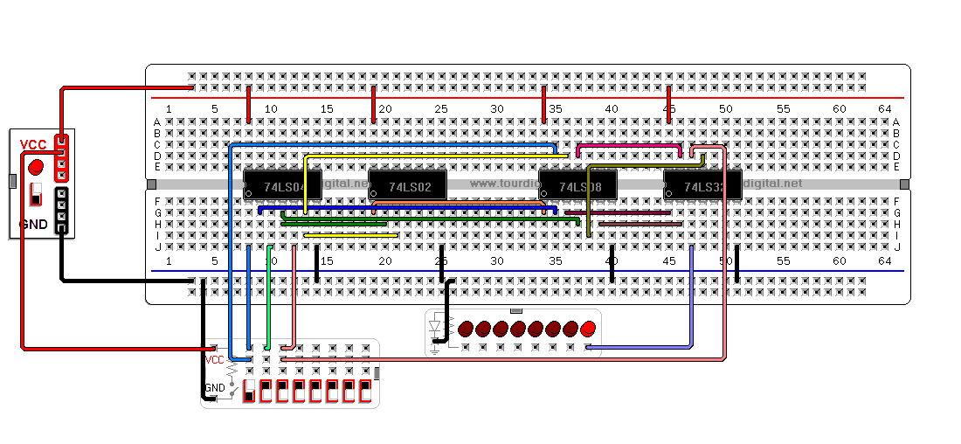

*n* = 5, 1 0 1

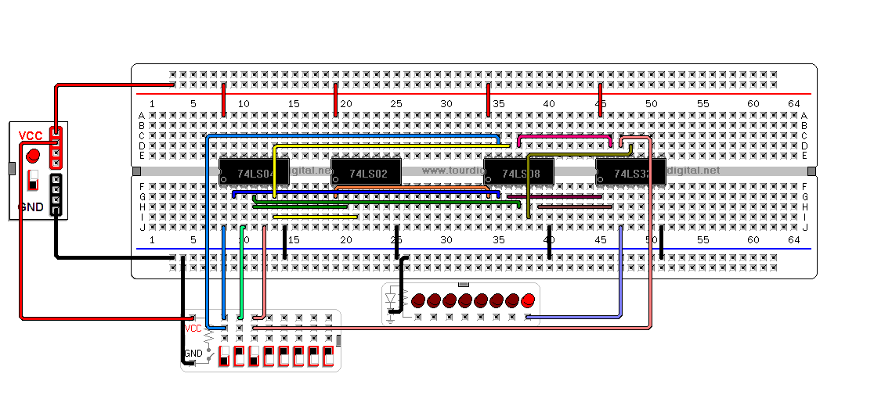

*Casos que no encienden*

*n* = 0, 0 0 0

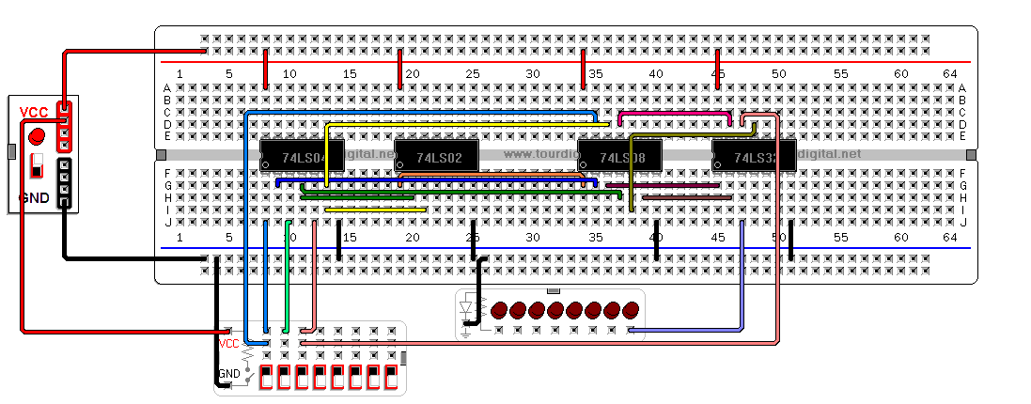

*n* = 2, 0 1 0

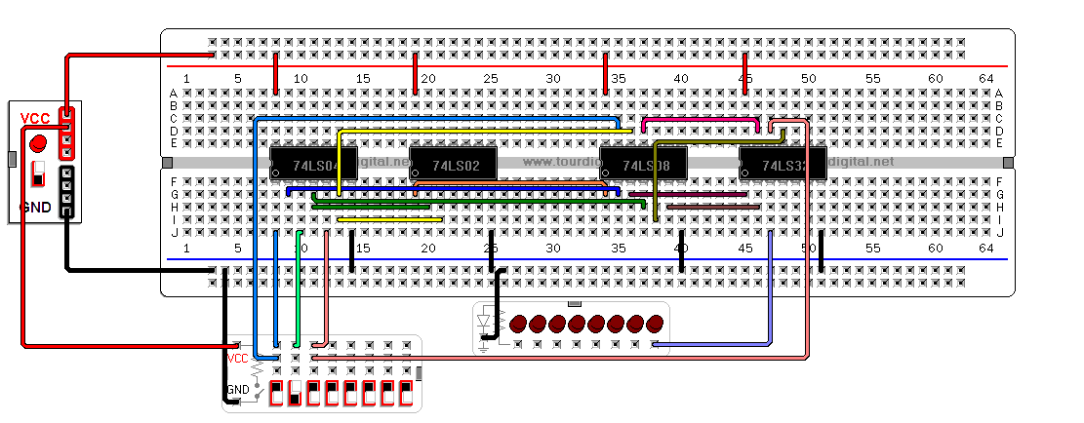

*n* = 6, 1 1 0

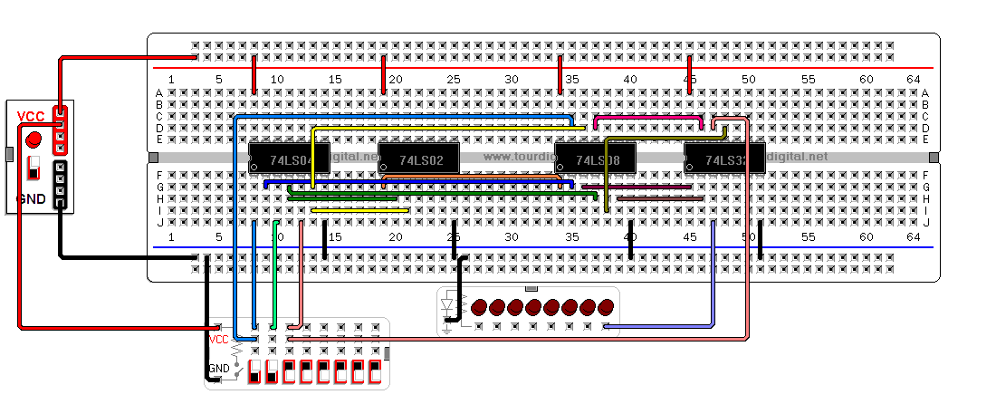

*n* = 7, 1 1 1

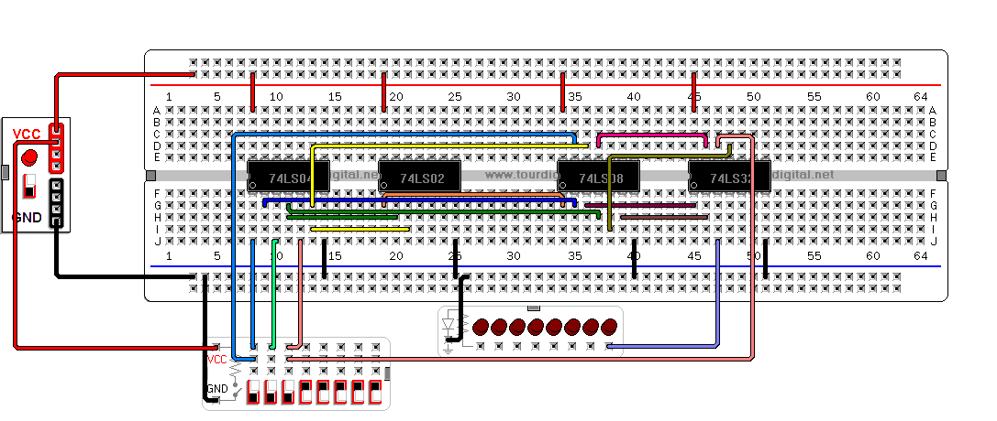

Circuito simplificado: *F* = *xy’*+*x’z*

*Casos que encienden.*

*n* = 1, 0 0 1

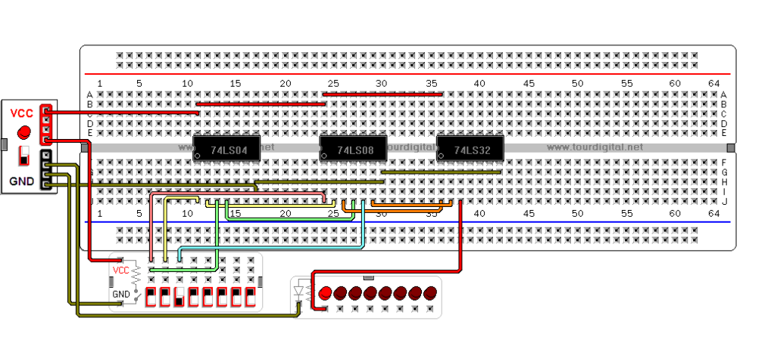

*n* = 3, 0 1 1

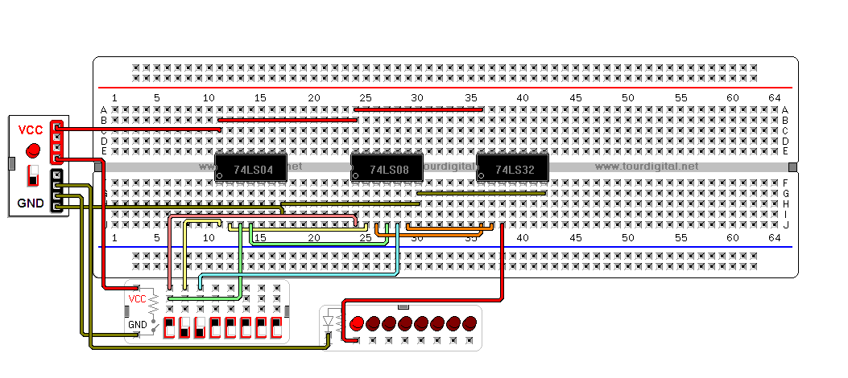

*n* = 4, 1 0 0

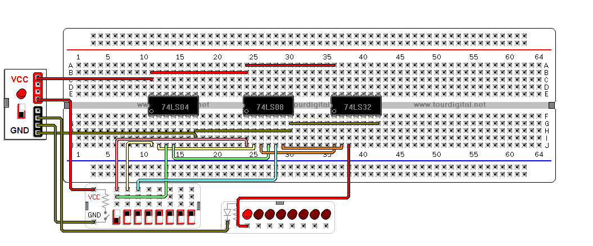

*n* = 5, 1 0 1

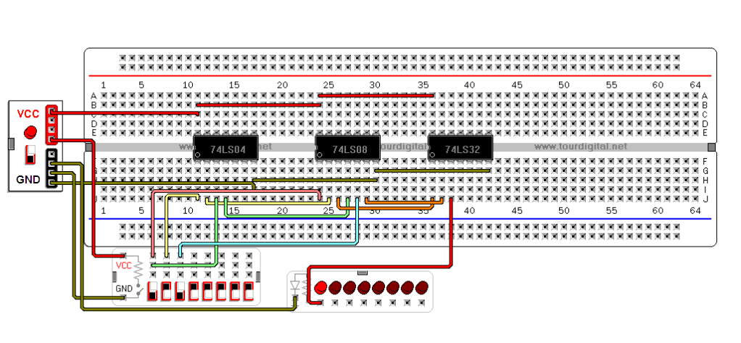

*Casos que no encienden*

*n* = 0, 0 0 0

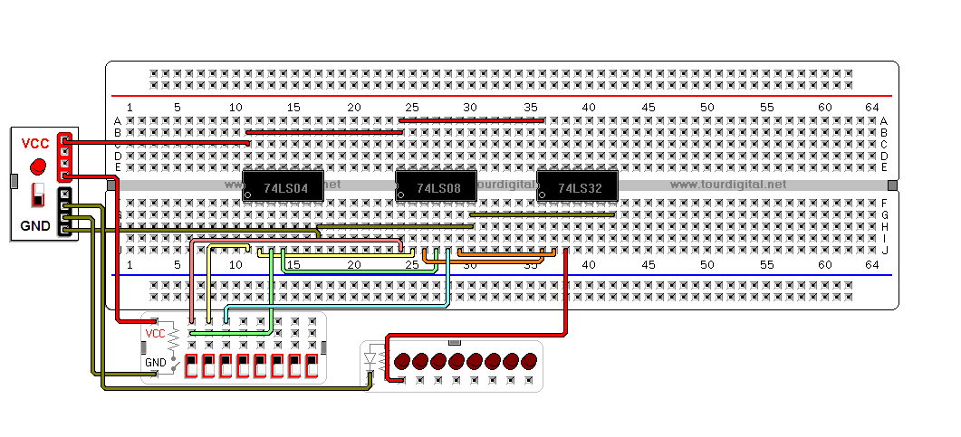

*n* = 2, 0 1 0

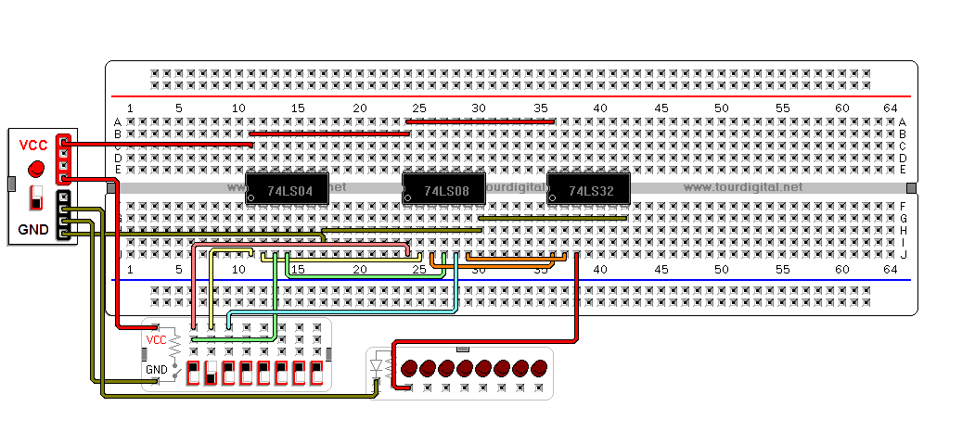

*n* = 6, 1 1 0

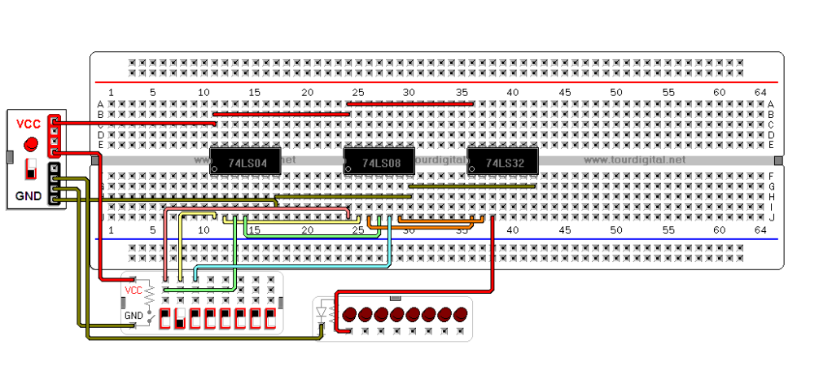

*n* = 7, 1 1 1

